Deluxe Grazing Boards
We order these from Deluxe Grazing. Their contact details are:
Alisha at 0411 129 492, and Monique at 0401 361 365.
deluxegrazing@outlook.com
You need to give the girls as much notice as possible. You should always receive the money from the guest prior to putting any order in. Please always remember that you need to allow for the Delivery pricing also and all of these prices are PLUS GST so the prices you see here you need to add 10% to it.
You will need to put the charge into Resly as a new Guest Charge
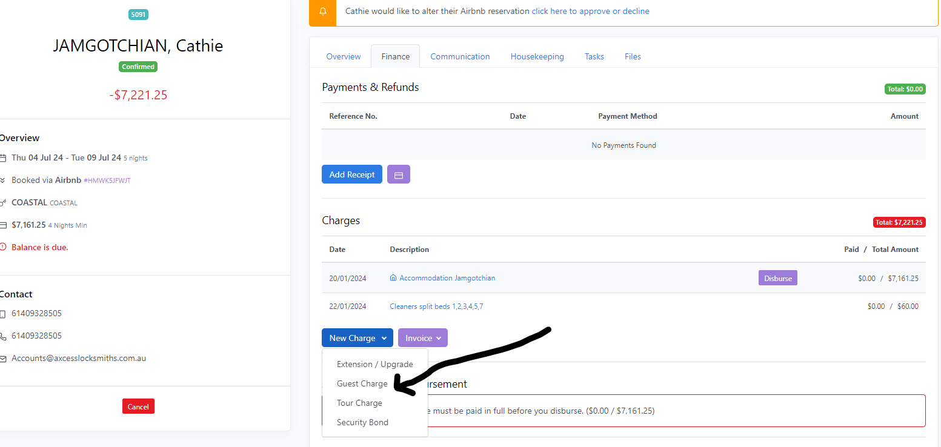
You need to put the correct amount in including the cost of the platter/box plus the cost of delivery plus GST. You then need to send a “balance due” email to the guest (however you will need to amend the wording to match this add on. The guest will need to pay prior to you booking in this service with Deluxe Grazing.
You then need to put into the Resly Notes that you have ordered a Deluxe Platter and also do a reminder scheduled email the day prior to remind Deluxe Grazing of the platter order and provide them with the codes for the property.
You will find any photos of Grazing Boards in Doc Central under MHC under Grazing boards. You can use these photos for sending to guests if needed.
You will also need to send a confirmation email to the guest once they have paid and you have ordered the boards.

